**Course Specialist Year 12 Test One 2022**

Student name: ________________ Teacher name: ________________

**Task type: Response**

**Time allowed for this task: _____40______ mins**

**Number of questions: _____8______**

**Materials required:** Calculator with CAS capability (to be provided by the student)

Standard items: Pens (blue/black preferred), pencils (including coloured), sharpener, correction fluid/tape, eraser, ruler, highlighters

Special items: Drawing instruments, templates, notes on one unfolded sheet of   
A4 paper, and up to three calculators approved for use in the WACE examinations

**Marks available: __42____ marks**

**Task weighting: _10___%**

**Formula sheet provided: Yes/No**

**Note: All part questions worth more than 2 marks require working to obtain full marks.**

Q1 (2, 3 & 3 = 8 marks) (3.1.1- 3.1.6)

Let  and .

Simplify the following.

1. 
2. 
3.  (simplify)

Q2 (3 marks) (3.1.1-3.1.3)

Determine all possible real number pairs  such that 

Q3 (3 marks) (3.1.13-3.1.15)

Consider the polynomial  where  are real numbers.

Given that  and  determine the values of .

Q4 (3 marks) (3.1.8-3.1.10)

Using the diagram below determine the complex number  in exact cartesian form.

(Note: Not drawn to scale)

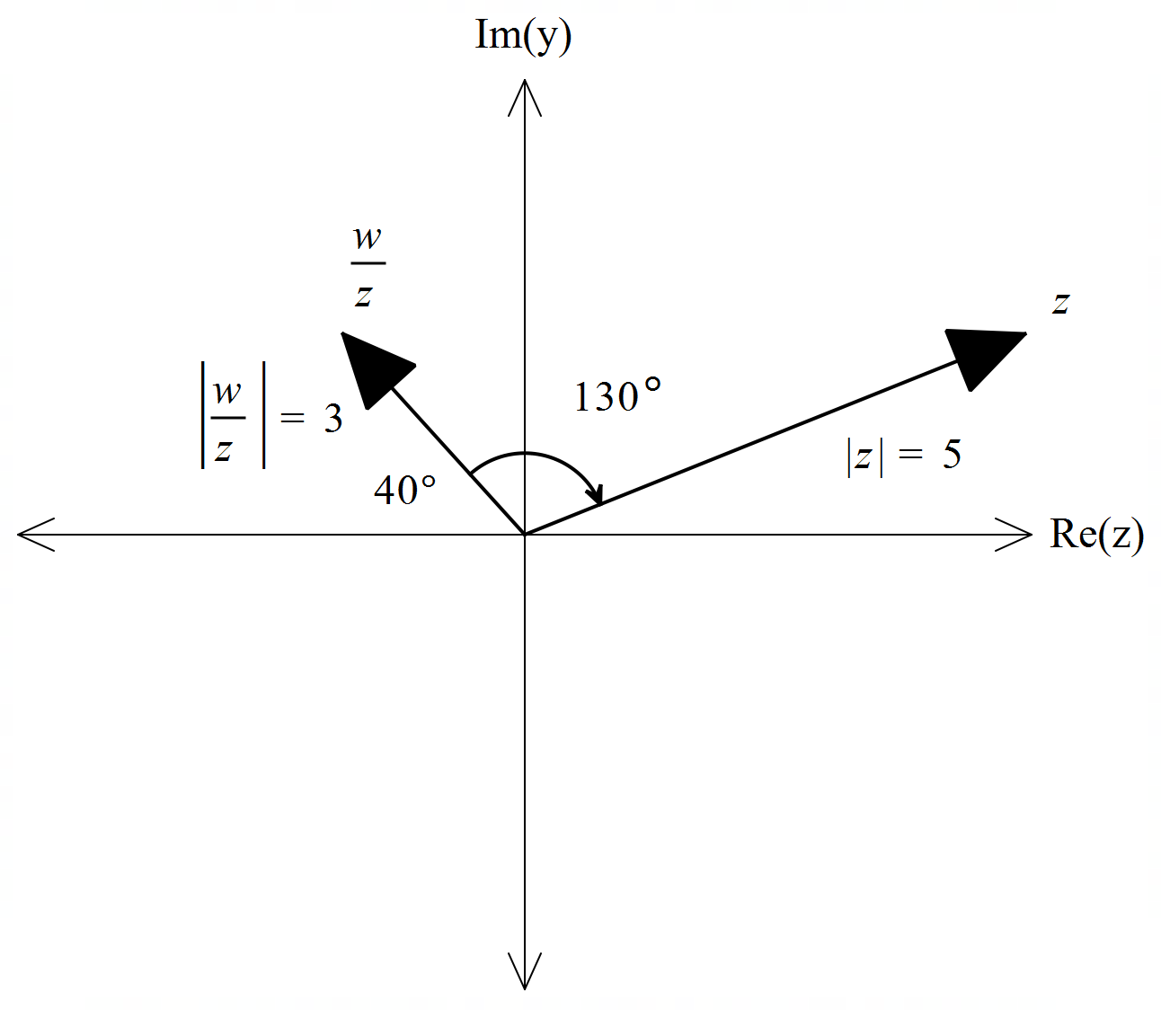

Q5 (3 & 3= 6 marks) (3.1.10)

Sketch the locus for the following labelling important features and points.

1. 

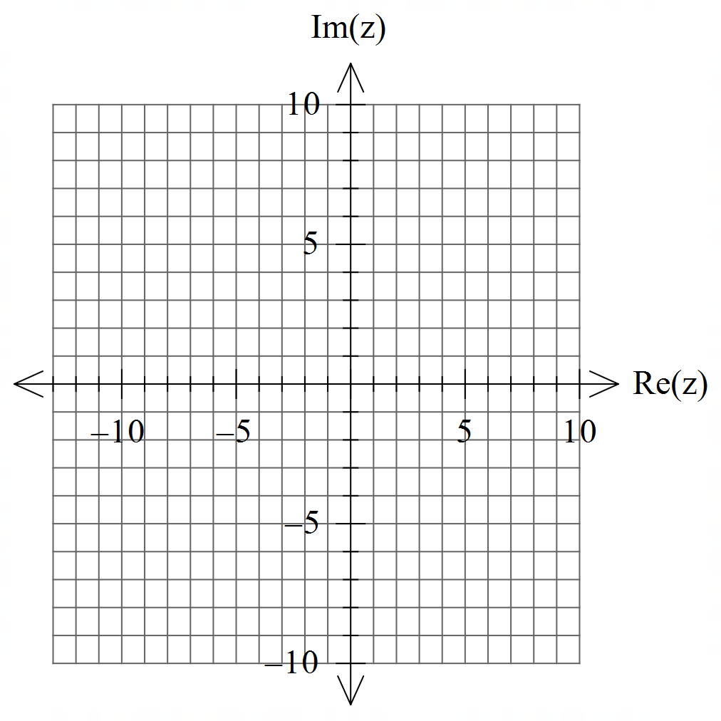

1. 

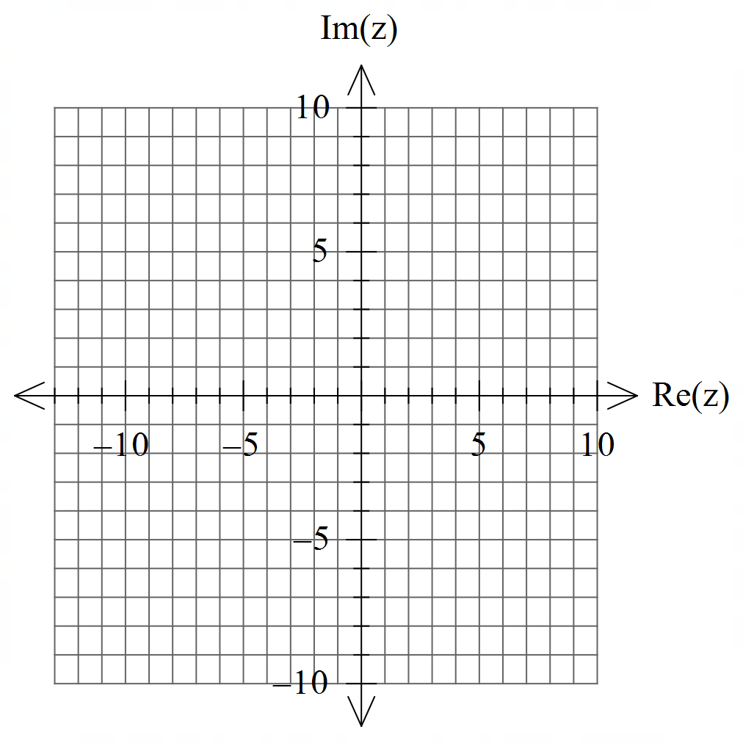

Q6 (2 & 4 = 6 marks) (3.1.10)

Consider the set of points  in the complex plane such that .

1. Determine the maximum value of .
2. Determine the maximum value of .

Q7 (4 marks) (3.1.7)

Using De Moivre’s Theorem, derive an expression for  in terms of .

Q8 (4, 2 & 3 = 9 marks) (3.1.11-3.1.12)

1. Solve for all the roots  in polar form  with .
2. Plot these roots on the complex plane below.

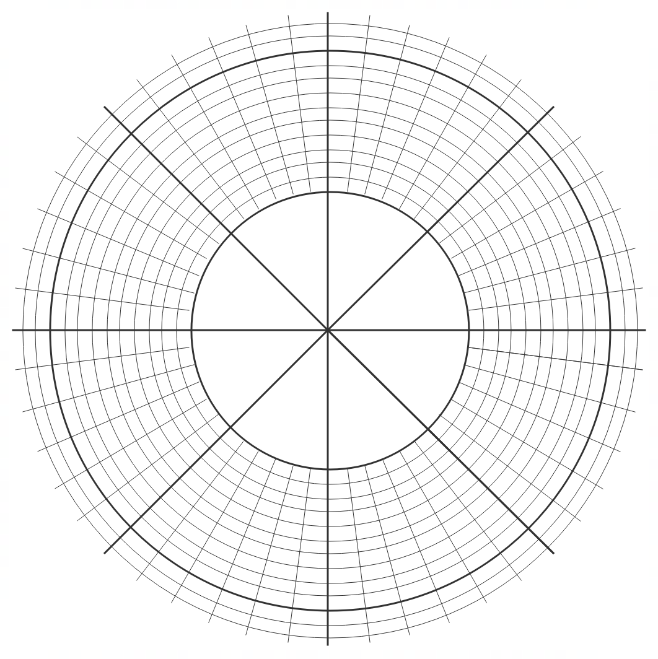

1. Adjacent points can be joined by lines to form a polygon. Determine the exact area of this polygon.

Working out space

Working out space